Road Accident Dashboard Training Document (Excel-Based)
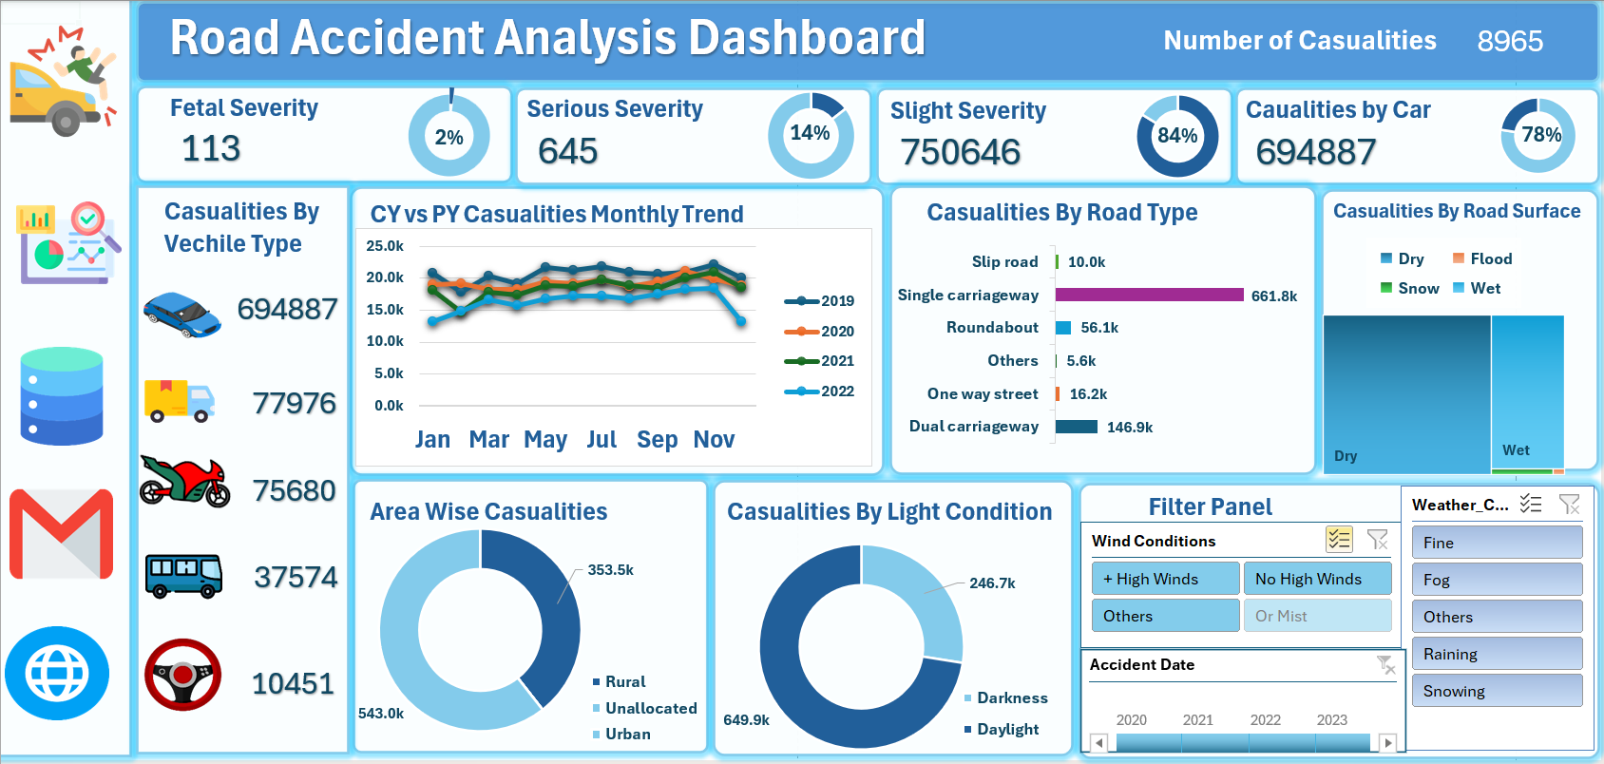

Purpose of the Dashboard
This dashboard is created to analyze and visualize road accident data across different factors such as accident severity, vehicle type, road type, lighting condition, and area type (urban/rural). It helps in identifying patterns and supporting data-driven decision-making for road safety initiatives.

Step-by-Step Structure to Build the Dashboard

PART 1: Primary KPIs Section
What we are making:
Visual blocks with key performance indicators (KPIs) to give a quick summary.
🔧 KPIs to Create:
- Total Casualties
- Fatal Casualties (Severe Deaths)
- Serious Casualties (Critical Injuries)
- Slight Casualties (Minor Injuries)
- Casualties by Cars
Visualizations:
- Use number cards (big bold values)
- Add donut charts (Data Labels ON, No Legends, % formatting)
- Insert icons or shapes to visually represent each KPI

PART 2: Secondary KPIs – Casualties by Vehicle Type
What we are making:
A summary of casualties grouped by type of vehicle.
🔧 Vehicle Groups:
- Cars
- Motorcycles
- Buses
- Trucks
- Tractors
- Others
Visualizations:
- Use icon + label combinations (SmartArt or manual shapes)
- Add small number cards below or beside each icon
- Use shapes or images of vehicle types from Excel Icons or Insert → Pictures

PART 3: CY vs PY Casualty Trend (Monthly)
What we are making:
A line chart comparing current year (CY) vs previous year (PY) month-wise data.
Visualizations:
- Use Line Chart
- X-axis: Month names (Jan to Dec)
- Y-axis: Casualty numbers
- Use two series: one for 2021, one for 2022
- Add Data Labels and Legend

PART 4: Casualties by Road Type
What we are making:
Compare accident counts across different road types.
Visualizations:
- Use Horizontal Bar Chart
- Categories: Single carriageway, Dual carriageway, Roundabout, One-way, Slip road, etc.
- Sort by descending order

PART 5: Casualties by Road Surface Condition
What we are making:
Show how many casualties occurred on dry, wet, or snow-covered roads.
Visualizations:
- Use Tree Map or 100% Stacked Bar
- Categories: Dry, Wet, Snow/Ice

PART 6: Urban vs Rural Casualties
What we are making:
Compare how many accidents happened in Urban vs Rural areas.
Visualizations:
- Use Donut Chart
- Two categories: Urban, Rural
- Highlight with contrasting colours (e.g., brown vs light beige)

PART 7: Light Condition Analysis (Day vs Night)
What we are making:
Determine when most accidents happen — during daylight or darkness.
Visualizations:
- Use Donut Chart
- Categories: Daylight, Darkness
- Show both count and percentage

PART 8: Filter Panel
What we are making:
Interactive panel to filter data based on:
- Urban or Rural
- Years (2021, 2022, 2023)
- Day of Week (Mon–Sun)
Visualizations:
- Use Slicers (Insert > Slicer from Pivot Table)
- Style them with custom colours matching your theme

PART 9: Linked Image Navigation
What we are making:
Clickable icons that navigate to the dataset or pivot pages.
How to do it:
- Insert image or icon (Insert > Icons or Pictures)
- Right-click > Link > Place in this Document > Select Sheet (e.g., Dataset)
- Add a small hover effect using formatting

Data Setup Recommendation
- Use Pivot Tables behind all visuals
- Store raw data in one clean sheet (RoadAccidentData)
- Name your ranges or use Excel Tables
- Use helper columns (e.g., Year, Month, Light, Road Type Group) for better analysis

Tools & Features Used
Feature | Use Case
Pivot Tables | Aggregating accident data
Pivot Charts | Creating dynamic visuals
Donut Charts | For % comparison
Line Charts | Time-series (month) analysis
Bar Charts | Category-wise comparisons
Slicers | Interactive filtering
Shapes/Icons | Visual storytelling & linking
Conditional Formatting | For colour indicators

